Evaluating the War of 1812
The War of 1812 is sometimes referred to as the Second War of Independence. How is the War of 1812 similar to the American Revolution that began in 1775? How did the War of 1812 change Americans' understanding of themselves and their place in the world?
Your answer must be in the form of a brief constructed response. You need a topic sentence with a claim. You need two arguments or main points for each question. Each should have at least two examples, evidence, facts, or quotes that support your thoughts. Finally, you need a conclusion that that refers back to your topic sentence and also makes a deeper connection to history or the present day.
Use complete sentences. Remember to be specific and detailed. Also, do not use any personal pronouns (I, me, my mine, you, etc.). Write in pen or typed (no more than 12-14 font size).
__________________________________________________________________________________________________________________________________________________________________________________________________________________________________________________________________________________________________________________________________________________________________________________________________________________________________________________________________________________________________________________________________________________________________________________________________________________________________________________________________________________________________________________________________________________________________________________________________________________________________________________________________________________________________________________________________________________________________________________________________________________________________________________________________________________________________________________________________________________________________________________________________________________________
The War of 1812
Flow Chart Rubric
Pre-War of 1812 5 pts.
Include at least five (5) events with dates that took place before the war and connected to the War of 1812. Include at least one event that did not come from the textbook or covered in lessons.
War & Post-War of 1812 5 pts.
Include at least five (5) events with dates that took place during and after the war. Include at least two events that did not come from the textbook or covered in lessons that connect to Michigan.
Appearance 5 pts.
The flow chart is laid out in the correct format (each event has its own box, events flow in order), free from spelling and grammatical errors, and is visually appealing.
War Hawks & Doves Comparison 4 pts
Evaluating the War Response 6 pts.
Total Points 25 _______/ 25
Name: ____________________________________ Date: ______________ Hour: ______
Purpose: The purpose of the assignment is to visually show the events that lead to and the events for the War of 1812.
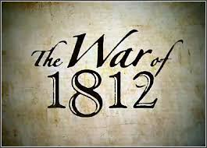
War and Post-War of 1812: Include events with dates that took place during the war. Include at least two events that did not come from the textbook/class that connect to Michigan History-cite!

Pre-War of 1812: Include at least five (5) events with dates that lead to the war. Include at least one event that did not come from the textbook/class-cite!
At least 5 total

Include events that took place during the war.
Dove
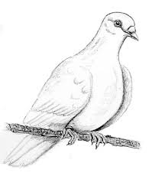
War Hawk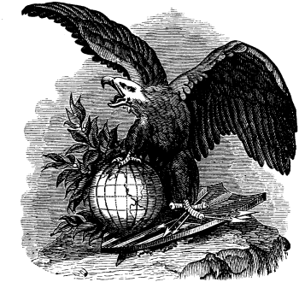
Differing Points of View: Include the two differing points of view (War Hawks vs. Doves). Explain their stance on the topic of war and name specific people who fell into these categories.

