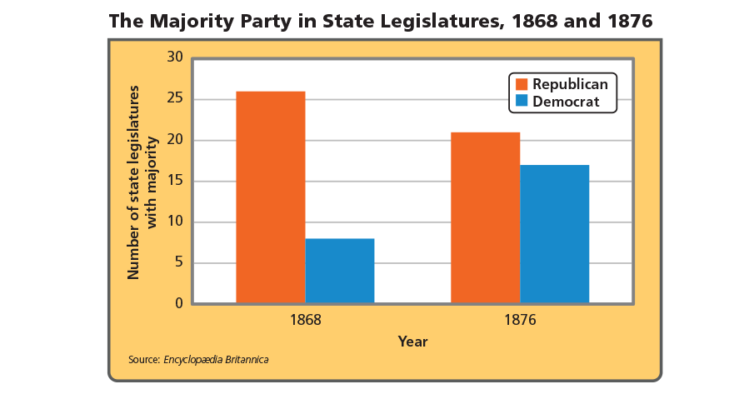
Analyze Graphs How did the representation of African Americans in these state legislatures likely change during the time period shown? Explain your answer.
____________________________________________________________________________________________________________________________________________________________________________________________________________________________________________________________________________________________
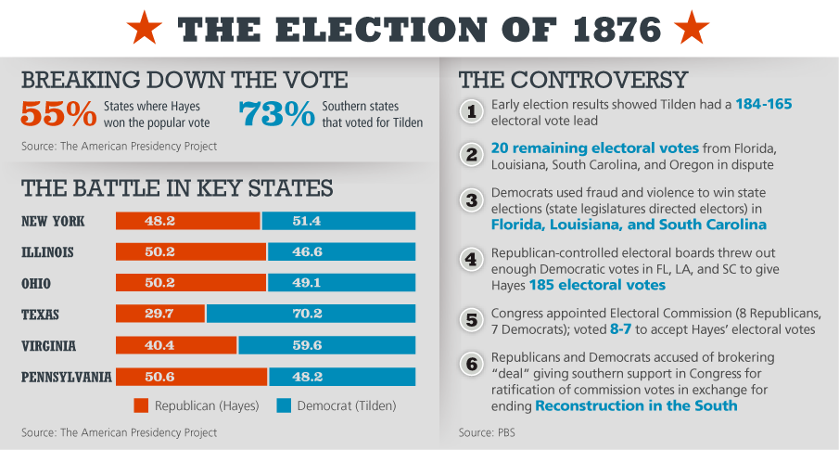
Analyze Information-Why was the outcome of the election of 1876 so controversial?
____________________________________________________________________________________________________________________________________________________________________________________________________________________________________________________________________________________________
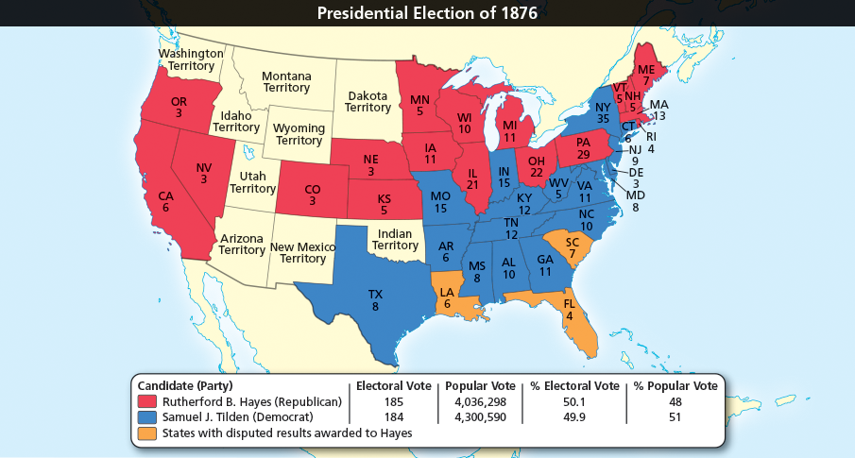
Analyze Maps Based on this map, do you think the Civil War brought an end to sectionalism?
________________________________________________________________________________________________________________________________________________________________________________________________________________________________________________________________________________________________________________________________
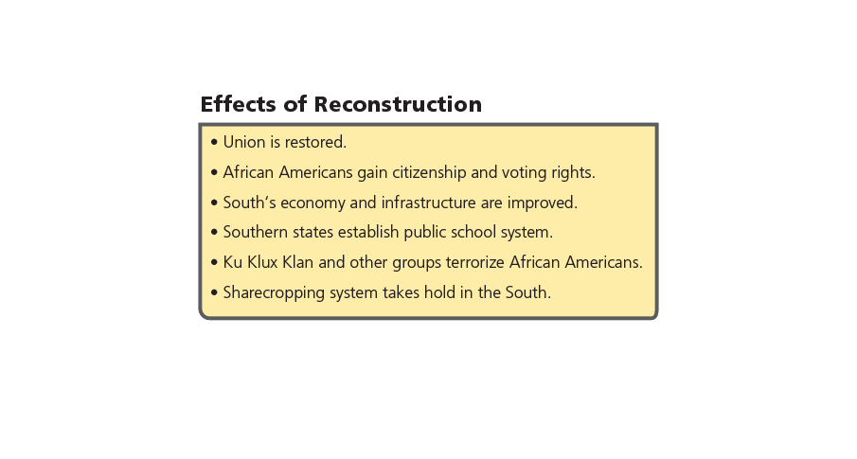
Analyze Information From the perspective of an African American in the South, how was Reconstruction a success and how was it a failure?
________________________________________________________________________________________________________________________________________________________________________________________________________________________________________________________________________________________________________________________________
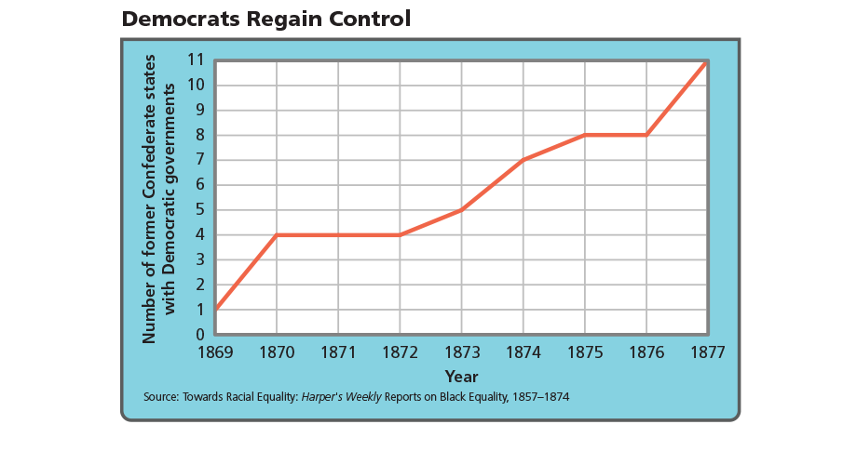
Analyze Charts Based on what you have learned about the South during Reconstruction, what reasons might explain the pattern shown here?
________________________________________________________________________________________________________________________________________________________________________________________________________________________________________________________________________________________________________________________________
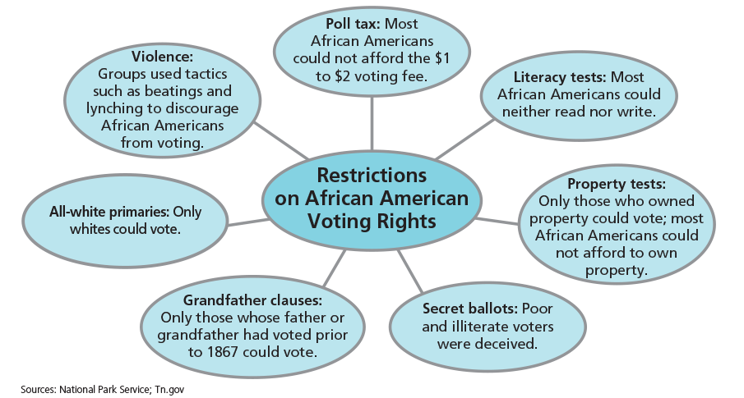
Analyze Information How were many white southerners protected from voting restrictions like these?
________________________________________________________________________________________________________________________________________________________________________________________________________________________________________________
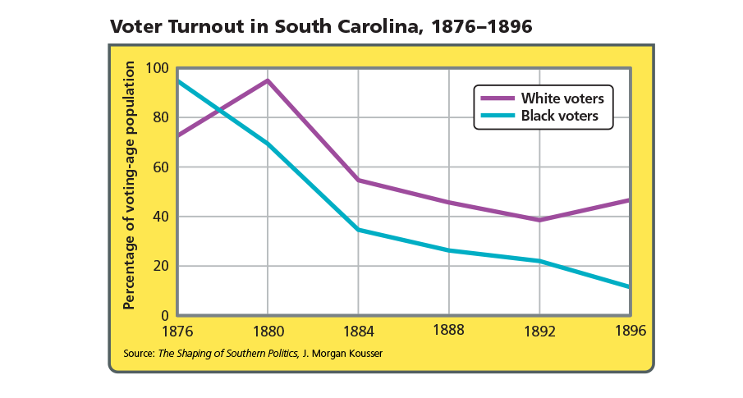
Analyze Graphs How were patterns of white and African American voter turnout similar and different during this time?
________________________________________________________________________________________________________________________________________________________________________________________________________________________________________________________________________________________________________________________________

