Key people and terms: Review the following BEFORE the test
Compromise of 1850 fugitive Wilmot Proviso
Jefferson Davis John Brown arsenal
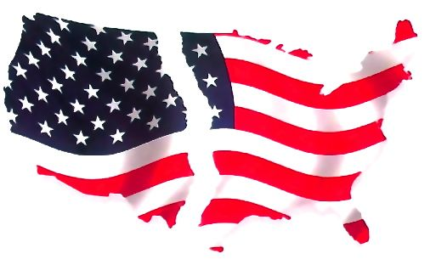
John C. Frémont Franklin Pierce civil war
Chapter 16 Study Guide – A Nation Divided
Sectionalism James Buchanan popular sovereignty

- What were the results of the Missouri Compromise?

- What are the parts of the Compromise of 1850?

- During the 1840s, what problem in the U.S was the worst: Sectionalism, nationalism, capitalism, or compromises?

- What did the Free Soil Party wanted to accomplish?

- Describe the Fugitive Slave Law of 1850.

- Was Uncle Tom’s Cabin a fiction or nonfiction story?

- What reversed the Missouri Compromise?

- What were the results of the Kansas-Nebraska Act?

- Describe the Dred Scott case?

- Why did John Brown attack the arsenal at Harper’s Ferry?

- What did southerners believe about the election of Lincoln?

- Why did some political leaders join together to form the Free Soil Party?

- What compromises are based on the principle of popular sovereignty?

- What did the Fugitive Slave Law and Uncle Tom’s Cabin caused many northerners to do?

- Why did the Dred Scott Decision anger northerners?
- Why did Lincoln win the election of 1860?

- What did Senator John Crittenden do in 1860?

- Who was the spokesperson over slavery in the Mexican Cession?

- Which of the following did the Kansas-Nebraska Act apply to: states’ rights, nullification, popular sovereignty, or universal suffrage?

- Why didn’t Lincoln use force against the Confederacy?

Familiarize yourself with the graphic on page 426

Essay Questions: You will be asked to answer the following essay questions.
- Why did the Southern states secede after the election of 1860?

- Why was the issue of slavery in the territories important to BOTH sides?

- What was the crisis that Lincoln faced when he took office? How did he handle it?

