Topic 5: The Early Republic
Name: Date: Hour:
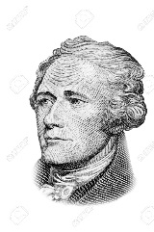
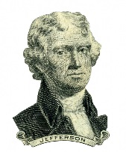
Directions: Use the chart below to compare and contrast the differing political beliefs between Alexander Hamilton and Thomas Jefferson.

Political Issue | Alexander Hamilton (Federalist) | Thomas Jefferson (Democratic Republican
What is their view on protective tariffs?

What type of system should our economy be bases off?

What type of people should lead the United States?

Should we have a national bank?

What governments should be stronger (State or Federal)?

What country should the United States model itself after? (Britain or France)

How should the Constitution be interpreted?

Whom would you have supported? Explain why using specific examples.
________________________________________________________________________________________________________________________________________________________________________________________________________________________________________________________________________________________________________________________________________________________________________________________________________________________________________________________________________________________________________________________________________________________________________________________________________________________________________________________________________________________________________________________________________________________________________________________________________________________________________________________________________________________________________________________________________________________________________________________________________________________________________________________________________________________________________________________________________________________________________________________________________________________________________________________________________________________________________________________________________________________________________________________________________________________________________________________________________________________________________________________________________________________________________________________________________________________________________________________________________________________________________________________________________________________________________________________________________________________________________________________________________________________________________________________________________________________________________________________________________________________________________________________________________________________________________________________________________________________________________________________________________________________________

